2. 8-PUZZLE PROBLEM
Aim
To write a Python program to solve the 8-Puzzle problem.
Objective
To arrange the tiles in the correct order by moving the blank space.
Algorithm
1)Start.
2)Read the initial puzzle state from the user.
3)Set the goal state as (1, 2, 3, 4, 5, 6, 7, 8, 0).
4)Initialize the queue and visited set.
5)Remove the front state from the queue.
6)If the current state is the goal state, print the solution and stop.
7)Otherwise, generate all valid moves (Up, Down, Left, Right).
8)Add unvisited states to the queue.
9)Repeat Steps 5–8 until the goal is found or the queue becomes empty.
10)If the queue becomes empty, print "No Solution Exists."
11)Stop.

FLOWCHART

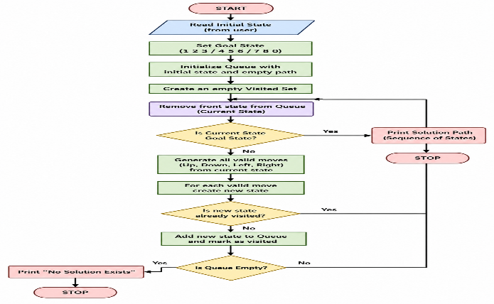

Python code:
class Puzzle:

def __init__(self, state, parent=None, level=0):
self.state = state
self.parent = parent
self.level = level

def find_blank(self):
for i in range(3):
for j in range(3):
if self.state[i][j] == '-':
return i, j

def heuristic(self, goal):
h = 0
for i in range(3):
for j in range(3):
if self.state[i][j] != '-':
value = self.state[i][j]
for x in range(3):
for y in range(3):
if goal[x][y] == value:
h += abs(i - x) + abs(j - y)
return h

def cost(self, goal):
return self.level + self.heuristic(goal)

def generate_children(self):
children = []
x, y = self.find_blank()

moves = [(-1,0),(1,0),(0,-1),(0,1)]

for dx, dy in moves:
nx, ny = x + dx, y + dy

if 0 <= nx < 3 and 0 <= ny < 3:
new_state = [row[:] for row in self.state]
new_state[x][y], new_state[nx][ny] = new_state[nx][ny], new_state[x][y]
children.append(Puzzle(new_state, self, self.level + 1))

return children

def display(state):
for row in state:
print(" ".join(row))
print()

def solve(start, goal):

open_list = [Puzzle(start)]
closed_list = []

while open_list:

open_list.sort(key=lambda x: x.cost(goal))

current = open_list.pop(0)

display(current.state)

if current.state == goal:
print("Goal State Reached!")
return

closed_list.append(current.state)

for child in current.generate_children():
if child.state not in closed_list:
open_list.append(child)

print("No Solution Found")

print("Enter Initial State (use - for blank):")
start = []
for i in range(3):
start.append(input().split())

print("\nEnter Goal State:")
goal = []
for i in range(3):
goal.append(input().split())

print("\nSolution Steps:\n")
solve(start, goal)

Output:
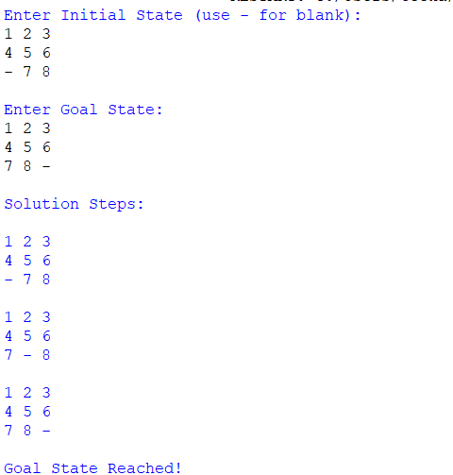

Result:
Thus, the Python program to solve the 8-Puzzle problem was executed successfully.

